# 1 Implementing Linear Regression to predict housing prices based on features
# a. Import the “House Price Prediction” data and analyse it with the help of
# b. Carry out the required steps of data pre-processing and do necessary Visu # c. Split the data and train the data with the Linear Regression model.
# d. Make the predictions and evaluate it on the test data.
Slip 1 In [1]:
# ==============================
# Step 1: Import Libraries
# ==============================
import pandas as pd import numpy as np
import matplotlib.pyplot as plt import seaborn as sns
from sklearn.model_selection import train_test_split from sklearn.linear_model import LinearRegression from sklearn.metrics import mean_squared_error, r2_score
In [2]:
# ==============================  # Step 2: Load Dataset  # ============================== data = pd.read_excel("/content/mlr.xlsx")  print("First 5 rows:") print(data.head())  print("\nDataset Info:") print(data.info())  print("\nStatistical Summary:")  print(data.describe()) | # change path if needed
In [3]:
First 5 rows:
Square_Feet Num_Bedrooms Num_Bathrooms Year_Built Lot_Size \
- 1360 2 1 1981 1.088566
- 4272 3 3 2016 4.780457
- 3592 1 2 2016 3.786509
- 966 1 2 1977 2.982815
- 4926 2 1 1993 4.732509
Garage_Size Neighborhood_Quality Location House_Price
- 0 5 chennai 6.084810e+05
- 1 6 bangalore 1.768604e+06
- 0 9 chennai 1.298508e+06
- 1 8 chennai 6.517251e+05
- 0 8 mumbai 1.918317e+06
Dataset Info:
<class 'pandas.core.frame.DataFrame'>
RangeIndex: 1000 entries, 0 to 999 Data columns (total 9 columns):
# Column Non-Null Count Dtype
--- ------ -------------- -----
- Square_Feet 1000 non-null int64
- Num_Bedrooms 1000 non-null int64
- Num_Bathrooms 1000 non-null int64
- Year_Built 1000 non-null int64
- Lot_Size 1000 non-null float64
- Garage_Size 1000 non-null int64
- Neighborhood_Quality 1000 non-null int64
- Location 1000 non-null object
- House_Price 1000 non-null float64 dtypes: float64(2), int64(6), object(1)
memory usage: 70.4+ KB None
Statistical Summary:
Square_Feet Num_Bedrooms Num_Bathrooms Year_Built Lot_Size \ count 1000.000000 1000.000000 1000.000000 1000.000000 1000.000000 mean 2815.422000 2.990000 1.973000 1986.550000 3.024967 std 1255.514921 1.427564 0.820332 20.632916 1.153692 min 503.000000 1.000000 1.000000 1950.000000 1.005385 25% 1749.500000 2.000000 1.000000 1969.000000 2.036396
50% 2862.500000 3.000000 2.000000 1986.000000 3.053102 75% 3849.500000 4.000000 3.000000 2004.250000 4.042949 max 4999.000000 5.000000 3.000000 2022.000000 4.990491
Garage_Size Neighborhood_Quality House_Price count 1000.000000 1000.000000 1.000000e+03 mean 1.022000 5.615000 1.187295e+06 std 0.814973 2.887059 3.956232e+05 min 0.000000 1.000000 2.675197e+05 25% 0.000000 3.000000 8.731123e+05
# ==============================
# Step 3: Data Preprocessing
# ==============================
# Check missing values print("\nMissing Values:") print(data.isnull().sum())
# Convert categorical variable 'Location' into numerical data = pd.get_dummies(data, columns=['Location'], drop_first=True)
print("\nColumns after encoding:")
print(data.columns)
50% 1.000000 6.000000 1.196792e+06 75% 2.000000 8.000000 1.503052e+06 max 2.000000 10.000000 2.084203e+06 In [4]:
Missing Values:
Square_Feet 0
Num_Bedrooms 0
Num_Bathrooms 0
Year_Built 0
Lot_Size 0
Garage_Size 0
Neighborhood_Quality 0
Location 0
House_Price 0 dtype: int64
Columns after encoding:
Index(['Square_Feet', 'Num_Bedrooms', 'Num_Bathrooms', 'Year_Built',
'Lot_Size', 'Garage_Size', 'Neighborhood_Quality', 'House_Price',
'Location_chennai', 'Location_delhi', 'Location_mumbai',
'Location_pune'], dtype='object')
# ==============================
# Step 4: Data Visualization
# ==============================
# Correlation heatmap plt.figure(figsize=(10,7))
sns.heatmap(data.corr(), annot=True, cmap='coolwarm') plt.title("Feature Correlation Heatmap") plt.show()
# Scatter plot: Size vs Price plt.figure()
plt.scatter(data['Square_Feet'], data['House_Price']) plt.xlabel("Square Feet") plt.ylabel("House Price")
plt.title("Square Feet vs House Price") plt.show()
# Distribution of house prices plt.figure()
sns.histplot(data['House_Price'], bins=30, kde=True)
In [5]:
plt.title("House Price Distribution")
plt.show()
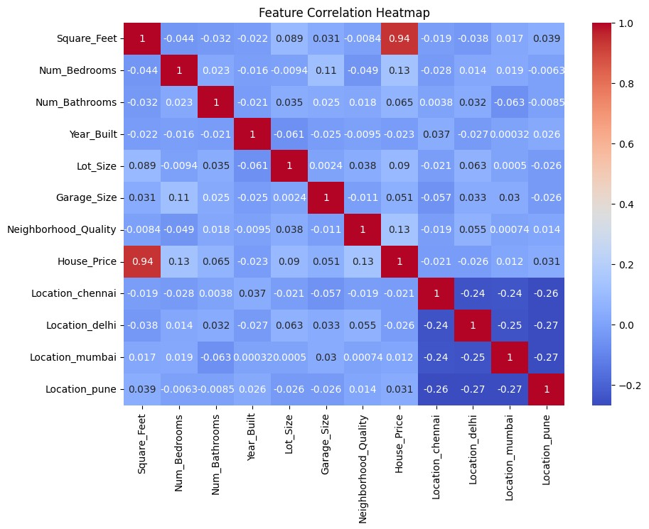

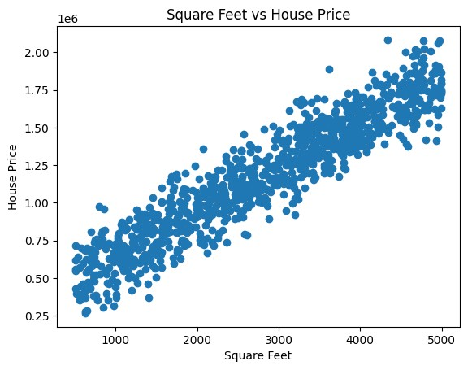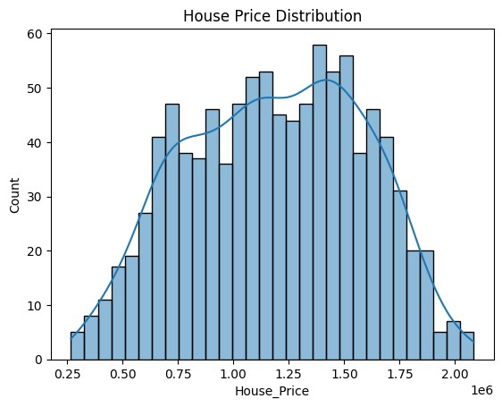

# ==============================
# Step 5: Split Dataset
# ==============================
X = data.drop("House_Price", axis=1) y = data["House_Price"]
X_train, X_test, y_train, y_test = train_test_split( X, y, test_size=0.2, random_state=42
)
print("Training Size:", X_train.shape) print("Testing Size:", X_test.shape)
In [6]:
Training Size: (800, 11)
Testing Size: (200, 11)
# ==============================
# Step 6: Train Linear Regression Model
# ==============================
model = LinearRegression() model.fit(X_train, y_train) print("\nModel Training Completed")
In [7]:
Model Training Completed
# ==============================
# Step 7: Prediction
# ============================== y_pred = model.predict(X_test)
print("\nFirst 10 Predictions:")
print(y_pred[:10])
In [8]:
First 10 Predictions:
[1501699.29351249 971151.03335785 1756901.75930418 1653110.78018493 1371892.90290653 1464039.43507711 1782822.08609159 1583872.17418435
1461764.88070823 1546421.42692164]
# ==============================
# Step 8: Model Evaluation
# ==============================
mse = mean_squared_error(y_test, y_pred) rmse = np.sqrt(mse) r2 = r2_score(y_test, y_pred)
print("\nModel Evaluation") print("Mean Squared Error:", mse) print("Root Mean Squared Error:", rmse) print("R2 Score:", r2)
In [9]:
Model Evaluation
Mean Squared Error: 12159433288.896313
Root Mean Squared Error: 110269.82039024237
R2 Score: 0.921107101493902
# ==============================
# Step 9: Actual vs Predicted Plot
# ==============================
plt.figure() plt.scatter(y_test, y_pred) plt.xlabel("Actual Price") plt.ylabel("Predicted Price")
plt.title("Actual vs Predicted House Prices")
plt.show()
In [10]:
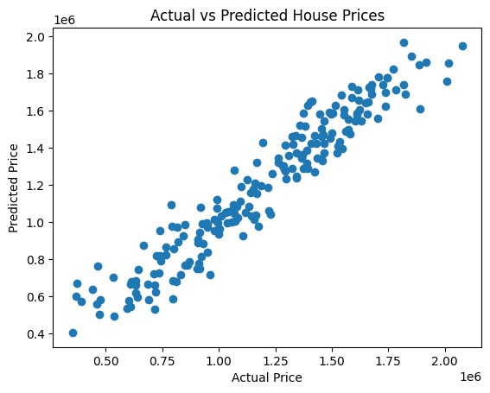

Slip 2
# Implementing the K-means clustering algorithm to identify distinct clusters # a customer demographic dataset.
# a) Import the “Mall Customers” data and plot Visualizations.
# b) Carry out the required steps of data pre-processing.
# c) Install the model and fit it on the data according to the parameters. # d) Show the final visualization of the clusters also find the number of # clusters to be defined.
In [11]:
# ==============================
# Step 1: Import Libraries
# ==============================
import pandas as pd import numpy as np
import matplotlib.pyplot as plt import seaborn as sns
from sklearn.cluster import KMeans from sklearn.preprocessing import LabelEncoder from sklearn.preprocessing import StandardScaler
# ==============================
# Step 2: Import Dataset
# ============================== data = pd.read_excel("clustering.xlsx")
print("First 5 rows:") print(data.head())
print("\nDataset Info:") print(data.info())
print("\nStatistical Summary:")
print(data.describe())
In [12]: In [13]:
First 5 rows:
CustomerID AnnualIncome SpendingScore Age Gender MembershipYears \
- 1 100569 11 26 Male 15
- 2 57220 51 25 Female 12
- 3 99062 83 19 Male 14
- 4 83251 64 36 Female 5
- 5 15063 33 58 Female 2
PurchaseFrequency
- 11
- 37
2 2
3 15
4Dataset Info: 17

<class 'pandas.core.frame.DataFrame'>
RangeIndex: 1000 entries, 0 to 999 Data columns (total 7 columns):
# Column Non-Null Count Dtype
--- ------ -------------- -----
- CustomerID 1000 non-null int64
- AnnualIncome 1000 non-null int64
- SpendingScore 1000 non-null int64
- Age 1000 non-null int64
- Gender 1000 non-null object
- MembershipYears 1000 non-null int64
- PurchaseFrequency 1000 non-null int64 dtypes: int64(6), object(1) memory usage: 54.8+ KB None
Statistical Summary:
CustomerID AnnualIncome SpendingScore Age MembershipYears
\
count 1000.000000 1000.000000 1000.000000 1000.00000 1000.000000 mean 500.500000 66088.510000 49.725000 43.40600 10.137000 std 288.819436 30445.776406 28.109705 14.97496 5.543551 min 1.000000 15063.000000 1.000000 18.00000 1.000000 25% 250.750000 38554.500000 26.000000 30.00000 5.000000
50% 500.500000 66141.000000 49.000000 43.00000 10.000000 75% 750.250000 93336.250000 73.000000 56.00000 15.000000 max 1000.000000 119898.000000 99.000000 69.00000 19.000000
PurchaseFrequency
count 1000.00000 mean 25.17500 std 14.32395 min 1.00000 25% 13.00000
# ==============================
# Step 3: Data Visualization
# ==============================
# Income vs Spending Score plt.figure()
plt.scatter(data["AnnualIncome"], data["SpendingScore"]) plt.xlabel("Annual Income") plt.ylabel("Spending Score") plt.title("Income vs Spending Score") plt.show()
# Age Distribution plt.figure()
sns.histplot(data["Age"], bins=20, kde=True) plt.title("Age Distribution")
plt.show()
50% 26.00000 75% 38.00000 max 49.00000 In [14]:
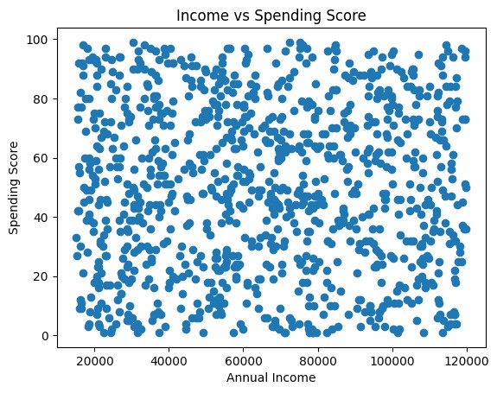
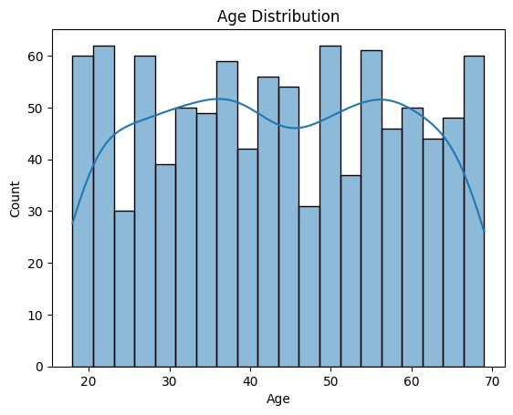
# ==============================
# Step 4: Data Preprocessing
# ==============================
# Convert Gender to numeric le = LabelEncoder()
data["Gender"] = le.fit_transform(data["Gender"])
# Remove CustomerID (not useful for clustering) data = data.drop("CustomerID", axis=1)
# Feature Scaling scaler = StandardScaler()
scaled_data = scaler.fit_transform(data)
# ==============================
# Step 5: Find Optimal Number of Clusters (Elbow Method)
# ==============================
wcss = []
for i in range(1,11):
kmeans = KMeans(n_clusters=i, random_state=42)
kmeans.fit(scaled_data) wcss.append(kmeans.inertia_)
In [15]: In [16]:
plt.figure()
plt.plot(range(1,11), wcss, marker='o') plt.xlabel("Number of Clusters")
plt.ylabel("WCSS") plt.title("Elbow Method")
plt.show()
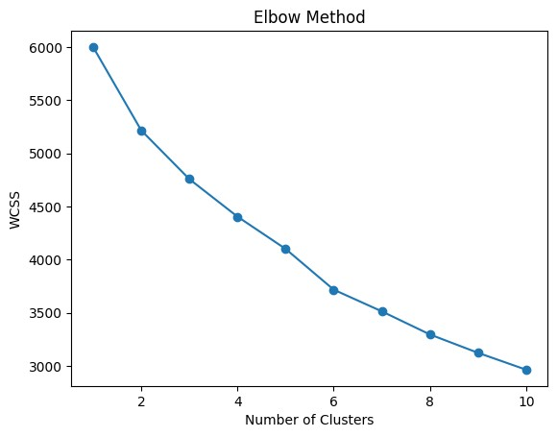
# ==============================
# Step 6: Train K-Means Model
# ==============================
kmeans = KMeans(n_clusters=5, random_state=42) clusters = kmeans.fit_predict(scaled_data) data["Cluster"] = clusters
print("\nClustered Data:")
print(data.head())
In [17]:
Clustered Data:
AnnualIncome SpendingScore Age Gender MembershipYears \
- 100569 11 26 1 15
- 57220 51 25 0 12
- 99062 83 19 1 14
- 83251 64 36 0 5
- 15063 33 58 0 2
PurchaseFrequency Cluster
- 11 4
- 37 3
- 2 1
- 15 4
- 17 2
# ==============================
# Step 7: Final Cluster Visualization
# ============================== plt.figure()
plt.scatter(data["AnnualIncome"], data["SpendingScore"], c=data["Cluster"])
plt.xlabel("Annual Income") plt.ylabel("Spending Score")
plt.title("Customer Clusters (K-Means)") plt.show()
In [18]:
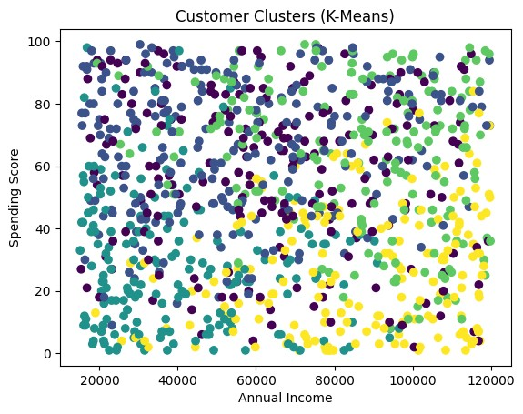

Slip 3
# Building a decision tree model using the ID3 algorithm to predict whether a # customer will churn or not.
# a) Import the “Churn” data and analyse it with the help of pre-defined # functions.
# b) Carry out the required steps of data pre-processing and do necessary # Visualizations.
# c) Split the data and fit it with the Decision Tree model (use the model # from “sklearn” library).
# d) Make the predictions and evaluate it on the test data.
In [19]:
# ==============================
# Step 1: Import Libraries
# ==============================
import pandas as pd import numpy as np
import matplotlib.pyplot as plt import seaborn as sns
from sklearn.model_selection import train_test_split from sklearn.preprocessing import LabelEncoder from sklearn.tree import DecisionTreeClassifier
from sklearn.metrics import accuracy_score, classification_report, confusion_m
In [20]:
# ==============================
# Step 2: Import Dataset
# ============================== data = pd.read_csv("churn.csv")
print("First 5 Rows:") print(data.head())
print("\nDataset Info:") print(data.info())
print("\nStatistical Summary:") print(data.describe())
print("\nMissing Values:") print(data.isnull().sum())
In [21]:
First 5 Rows:
CustomerID Age Gender Tenure Usage Frequency Support Calls \
- 1 22 Female 25 14 4
- 2 41 Female 28 28 7
- 3 47 Male 27 10 2
- 4 35 Male 9 12 5
- 5 53 Female 58 24 9
Payment Delay Subscription Type Contract Length Total Spend \
- 27 Basic Monthly 598
- 13 Standard Monthly 584
- 29 Premium Annual 757
- 17 Premium Quarterly 232
- 2 Standard Annual 533
Last Interaction Churn
- 9 1
- 20 0
- 21 0
- 18 0
- 18 0

Dataset Info:
<class 'pandas.core.frame.DataFrame'>
RangeIndex: 64374 entries, 0 to 64373 Data columns (total 12 columns):
# Column Non-Null Count Dtype
--- ------ -------------- -----
- CustomerID 64374 non-null int64
- Age 64374 non-null int64
- Gender 64374 non-null object
- Tenure 64374 non-null int64
- Usage Frequency 64374 non-null int64
- Support Calls 64374 non-null int64
- Payment Delay 64374 non-null int64
- Subscription Type 64374 non-null object
- Contract Length 64374 non-null object
- Total Spend 64374 non-null int64
- Last Interaction 64374 non-null int64
- Churn 64374 non-null int64 dtypes: int64(9), object(3) memory usage: 5.9+ MB None
Statistical Summary:
CustomerID Age Tenure Usage Frequency \ count 64374.000000 64374.000000 64374.000000 64374.000000 mean 32187.500000 41.970982 31.994827 15.080234 std 18583.317451 13.924911 17.098234 8.816470 min 1.000000 18.000000 1.000000 1.000000 25% 16094.250000 30.000000 18.000000 7.000000
50% 32187.500000 42.000000 33.000000 15.000000 75% 48280.750000 54.000000 47.000000 23.000000 max 64374.000000 65.000000 60.000000 30.000000 Support Calls Payment Delay Total Spend Last Interaction \ count 64374.000000 64374.000000 64374.000000 64374.000000 mean 5.400690 17.133952 541.023379 15.498850 std 3.114005 8.852211 260.874809 8.638436 min 0.000000 0.000000 100.000000 1.000000 25% 3.000000 10.000000 313.000000 8.000000
50% 6.000000 19.000000 534.000000 15.000000 75% 8.000000 25.000000 768.000000 23.000000 max 10.000000 30.000000 1000.000000 30.000000
Churn
count 64374.000000 mean 0.473685 std 0.499311 min 0.000000 25% 0.000000
50% 0.000000 75% 1.000000 max 1.000000
Missing Values:
CustomerID 0
Age 0
Gender 0
Tenure 0
Usage Frequency 0
Support Calls 0
Payment Delay 0
Subscription Type 0
Contract Length 0
Total Spend 0
Last Interaction 0 Churn 0 dtype: int64
# ==============================
# Step 3: Data Visualization
# ==============================
# Churn distribution plt.figure() sns.countplot(x='Churn', data=data) plt.title("Churn Distribution") plt.show()
# Correlation Heatmap plt.figure(figsize=(10,6))
sns.heatmap(data.corr(numeric_only=True), annot=True, cmap='coolwarm') plt.title("Correlation Heatmap")
plt.show()
In [22]:

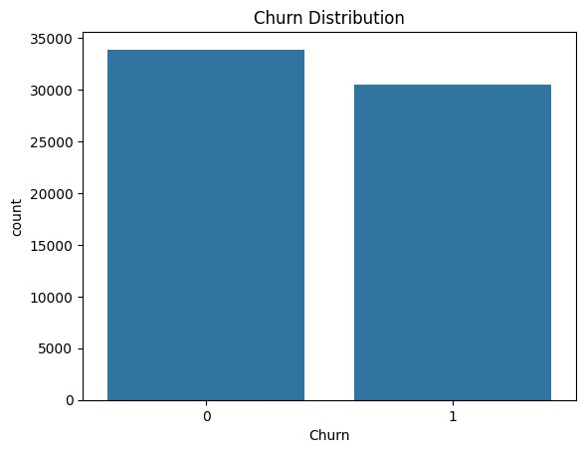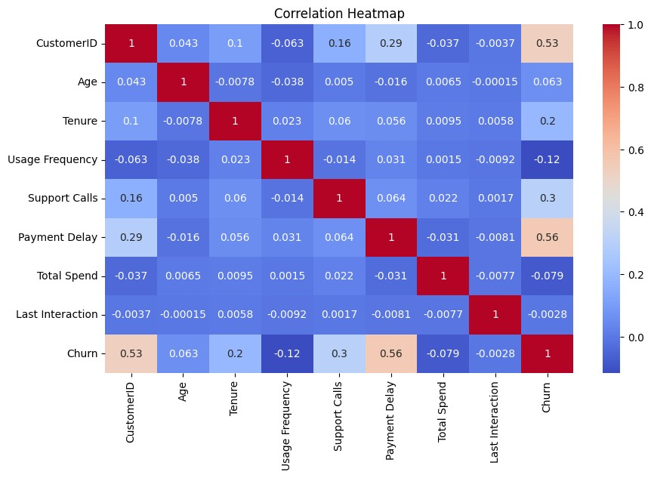

# ==============================
# Step 4: Data Preprocessing
# ==============================
# Convert categorical columns to numeric le = LabelEncoder()
for column in data.columns:
if data[column].dtype == 'object':
data[column] = le.fit_transform(data[column])
# Features and Target
X = data.drop("Churn", axis=1) y = data["Churn"]
In [23]:
# ==============================
# Step 5: Split Dataset
# ==============================
X_train, X_test, y_train, y_test = train_test_split( X, y, test_size=0.2, random_state=42
)
print("Training Data Shape:", X_train.shape) print("Testing Data Shape:", X_test.shape)
In [24]:
Training Data Shape: (51499, 11)
Testing Data Shape: (12875, 11)
# ==============================
# Step 6: Train Decision Tree Model (ID3)
# ============================== model = DecisionTreeClassifier(criterion="entropy", random_state=42) model.fit(X_train, y_train) print("\nModel Training Completed")
In [25]:
Model Training Completed
# ==============================
# Step 7: Prediction
# ============================== y_pred = model.predict(X_test)
print("\nFirst 10 Predictions:")
print(y_pred[:10])
In [26]:
First 10 Predictions:
[0 0 1 0 0 0 0 0 1 0]
# ==============================
In [27]:
# Step 8: Model Evaluation
# ============================== accuracy = accuracy_score(y_test, y_pred) print("\nModel Accuracy:", accuracy)
print("\nConfusion Matrix:")
print(confusion_matrix(y_test, y_pred))
print("\nClassification Report:")
print(classification_report(y_test, y_pred))
Model Accuracy: 0.9986796116504855
Confusion Matrix:
[[6784 9]
[ 8 6074]]
Classification Report: precision recall f1-score support
- 1.00 1.00 1.00 6793
- 1.00 1.00 1.00 6082
accuracy 1.00 12875 macro avg 1.00 1.00 1.00 12875 weighted avg 1.00 1.00 1.00 12875
# ==============================
# Step 9: Decision Tree Visualization
# ============================== from sklearn.tree import plot_tree
plt.figure(figsize=(15,8))
plot_tree(model, filled=True, feature_names=X.columns) plt.title("Decision Tree for Churn Prediction")
plt.show()
In [28]:
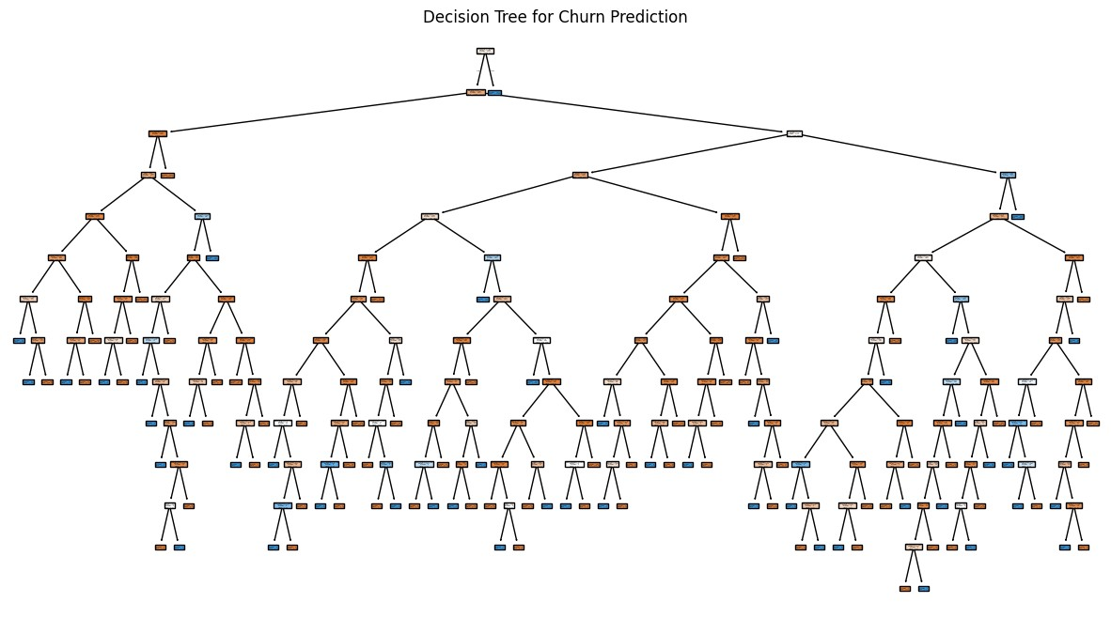
Slip 4
# Using logistic regression predict whether a credit card transaction is # fraudulent or not.
# a) Import the “Credit Card” data and remove the variables not required # for the processing.
# b) Split the data into training and validation data.
# c) Train the data on Logistic Regression model and predict for the test # data.
# d) Evaluate the predictions i.e. show the Confusion Matrix and Accuracy # Score of the model.
In [29]:
# ==============================
# Step 1: Import Libraries
# ==============================
import pandas as pd import numpy as np
import matplotlib.pyplot as plt import seaborn as sns
from sklearn.model_selection import train_test_split from sklearn.linear_model import LogisticRegression from sklearn.metrics import confusion_matrix, accuracy_score
In [30]:
# ==============================
# Step 2: Import Dataset
# ============================== data = pd.read_csv("creditcard.csv")
In [31]:

print("First 5 rows:") print(data.head())
print("\nDataset Info:") print(data.info())
print("\nClass Distribution:") print(data["Class"].value_counts())

First 5 rows:
Time V1 V2 V3 V4 V5 V6 \
- 121958 0.486036 0.101723 -0.815592 -1.721047 -0.002736 -0.843590
- 146867 -1.547304 1.498012 -0.349863 -0.982416 -0.394599 -0.474763
- 131932 1.082691 -0.312836 0.649581 -0.430415 0.396706 1.254656
- 103694 -0.471125 1.030919 -0.342718 1.368189 -0.193658 1.796147
- 119879 -0.093636 -0.288063 1.078426 0.901144 -0.085176 -1.264686
V7 V8 V9 ... V21 V22 V23 V24 \
- 0.354177 -0.545922 1.117118 ... 0.088659 0.809815 0.139065 0.675980
- 0.483706 -1.404541 0.599804 ... -2.018395 1.165325 -1.998137 -0.797603
- 0.227148 -0.893522 -1.276280 ... 0.299506 0.014265 -0.239139 -1.432304
- -0.616184 -0.640656 0.447960 ... 0.610152 -0.232129 1.306864 0.490955
- -0.201492 -0.196552 1.047670 ... -0.459552 -0.070654 -1.066149 0.447087
V25 V26 V27 V28 Amount Class
- 1.365122 -1.952076 0.139163 -1.452492 157.89 0
- -0.028983 -0.389299 -0.235003 -0.179763 3.77 0
- 1.484852 0.707765 2.008292 -1.269684 251.68 0
- 0.839080 -0.166274 1.483266 -0.477960 3.94 0
- -0.418308 0.173153 -0.608651 -2.035171 1.70 0
[5 rows x 31 columns]
Dataset Info:
<class 'pandas.core.frame.DataFrame'>
RangeIndex: 5000 entries, 0 to 4999 Data columns (total 31 columns):
# Column Non-Null Count Dtype
--- ------ -------------- -----
- Time 5000 non-null int64
- V1 5000 non-null float64
- V2 5000 non-null float64
- V3 5000 non-null float64
- V4 5000 non-null float64
- V5 5000 non-null float64
- V6 5000 non-null float64
- V7 5000 non-null float64
- V8 5000 non-null float64
- V9 5000 non-null float64
- V10 5000 non-null float64
- V11 5000 non-null float64
- V12 5000 non-null float64
- V13 5000 non-null float64
- V14 5000 non-null float64
- V15 5000 non-null float64
- V16 5000 non-null float64
- V17 5000 non-null float64
- V18 5000 non-null float64
- V19 5000 non-null float64
- V20 5000 non-null float64
- V21 5000 non-null float64
- V22 5000 non-null float64
- V23 5000 non-null float64
- V24 5000 non-null float64
- V25 5000 non-null float64
- V26 5000 non-null float64
- V27 5000 non-null float64
- V28 5000 non-null float64
- Amount 5000 non-null float64
- Class 5000 non-null int64 dtypes: float64(29), int64(2) memory usage: 1.2 MB None
Class Distribution:
Class
  - 4900
  - 100
Name: count, dtype: int64
# ==============================
# Step 3: Remove Unnecessary Variables
# ==============================
# Time column usually not required data = data.drop("Time", axis=1)
In [32]:
# ==============================
# Step 4: Data Visualization
# ==============================
plt.figure() sns.countplot(x="Class", data=data) plt.title("Fraud vs Normal Transactions")
plt.show()
In [33]:
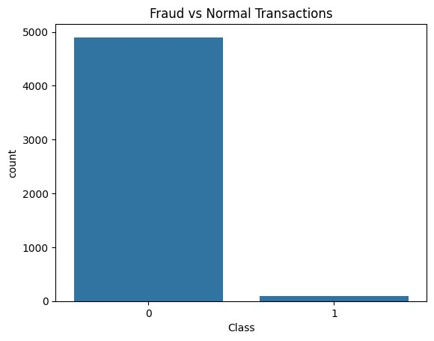
# ==============================
# Step 5: Define Features and Target
# ==============================
X = data.drop("Class", axis=1) y = data["Class"]
In [34]:
# ==============================
# Step 6: Split Dataset
# ==============================
X_train, X_test, y_train, y_test = train_test_split( X, y,
test_size=0.2, random_state=42
)
print("Training Shape:", X_train.shape) print("Testing Shape:", X_test.shape)
In [35]:
Training Shape: (4000, 29)
Testing Shape: (1000, 29)
# ==============================
# Step 7: Train Logistic Regression Model
# ==============================
In [36]:
model = LogisticRegression(max_iter=1000) model.fit(X_train, y_train) print("\nModel Training Completed")
Model Training Completed
# ==============================
# Step 8: Predictions
# ============================== y_pred = model.predict(X_test)
print("\nFirst 10 Predictions:")
print(y_pred[:10])
In [37]:
First 10 Predictions:
[0 0 0 0 0 0 0 0 0 0]
# ==============================
# Step 9: Model Evaluation
# ==============================
cm = confusion_matrix(y_test, y_pred) accuracy = accuracy_score(y_test, y_pred)
print("\nConfusion Matrix:") print(cm) print("\nAccuracy Score:", accuracy)
In [38]:
Confusion Matrix:
[[987 0]
[ 13 0]]
Accuracy Score: 0.987
# ==============================
# Step 10: Confusion Matrix Visualization
# ==============================
plt.figure()
sns.heatmap(cm, annot=True, fmt="d", cmap="Blues") plt.xlabel("Predicted") plt.ylabel("Actual") plt.title("Confusion Matrix")
plt.show()
In [39]:
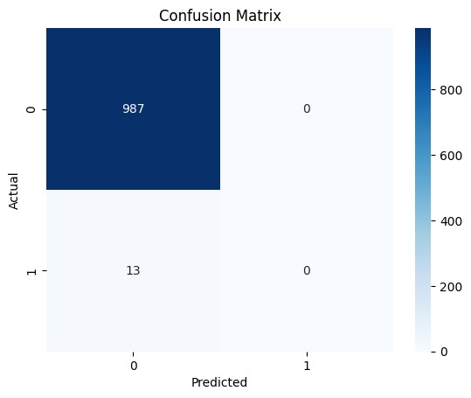
Slip 5
# Implementing a K-Nearest Neighbor (KNN) algorithm to classify handwritten # digits.
# a) Import the “Digits Classification” data and plot a figure to know the # data.
# b) Split the data into training and validation data also define the main # “KNN” function.
# c) Create the Euclidean and Accuracy Score functions and evaluate the # KNN model.
# d) Predict the test data and make a for loop to show few values and label # the model that are predicted.
In [40]:
# ==============================
# Step 1: Import Libraries
# ============================== import numpy as np
import matplotlib.pyplot as plt
from sklearn.datasets import load_digits
from sklearn.model_selection import train_test_split from sklearn.metrics import accuracy_score
# ==============================
In [41]:

# Step 2: Import Digits Dataset
# ============================== digits = load_digits()
X = digits.data y = digits.target print("Dataset Shape:", X.shape)
# Plot few digit images plt.figure(figsize=(8,4))
for i in range(5):
plt.subplot(1,5,i+1)
plt.imshow(digits.images[i], cmap='gray') plt.title("Label: " + str(y[i])) plt.axis('off') plt.show()
# ==============================
# Step 3: Split Dataset
# ==============================
X_train, X_test, y_train, y_test = train_test_split( X, y, test_size=0.2, random_state=42
)
print("Training samples:", len(X_train)) print("Testing samples:", len(X_test))
# ==============================
# Step 4: Euclidean Distance Function
# ==============================
def euclidean_distance(x1, x2): return np.sqrt(np.sum((x1 - x2) ** 2))
# ==============================
# Step 5: KNN Function
# ============================== def knn_predict(X_train, y_train, x_test, k=3):
distances = []
# Calculate distance from test point to all training points for i in range(len(X_train)):
dist = euclidean_distance(x_test, X_train[i]) distances.append((dist, y_train[i]))
# Sort distances
distances.sort(key=lambda x: x[0])
# Take k nearest neighbors neighbors = distances[:k] labels = [label for (_, label) in neighbors]
# Majority voting
prediction = max(set(labels), key=labels.count) return prediction
# ==============================
# Step 6: Predict Test Data
# ============================== predictions = []
for x in X_test:
pred = knn_predict(X_train, y_train, x, k=3) predictions.append(pred) predictions = np.array(predictions)
# ==============================
# Step 7: Evaluate Model
# ============================== accuracy = accuracy_score(y_test, predictions) print("Model Accuracy:", accuracy)
# ==============================
# Step 8: Show Few Predictions
# ============================== for i in range(10):
plt.imshow(X_test[i].reshape(8,8), cmap='gray') plt.title("Predicted: " + str(predictions[i])) plt.axis('off') plt.show()
Dataset Shape: (1797, 64)
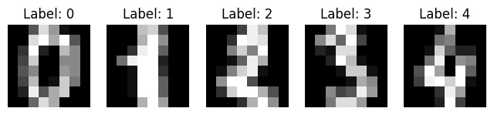
Training samples: 1437
Testing samples: 360
Model Accuracy: 0.9833333333333333
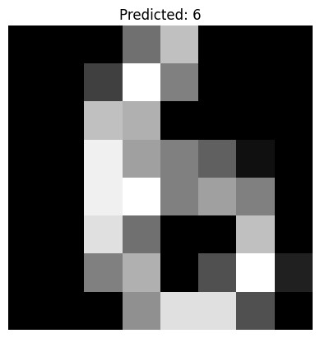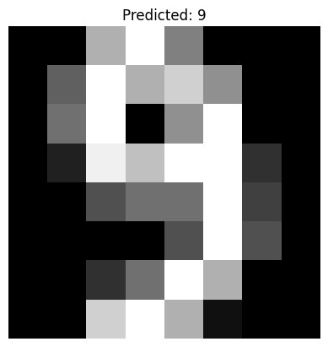

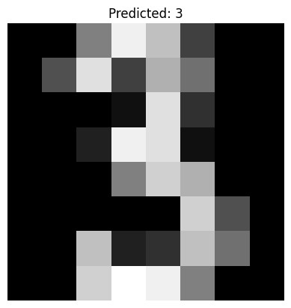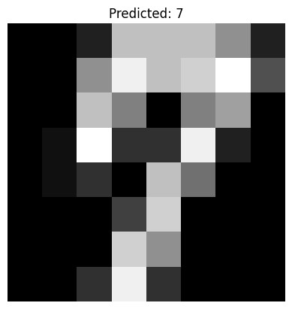
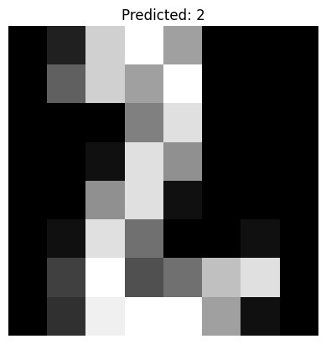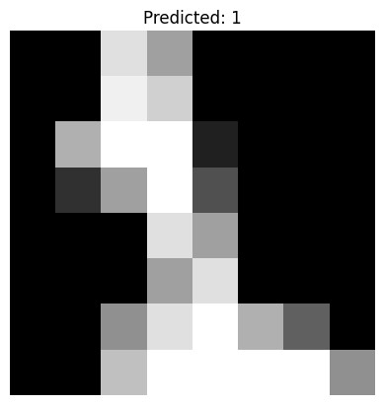
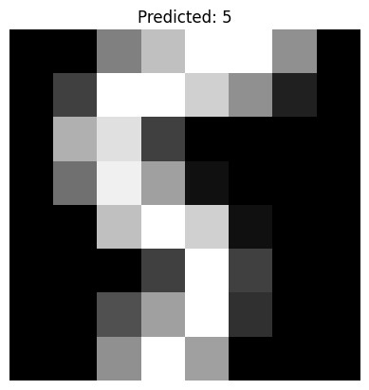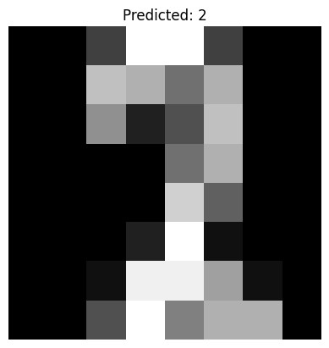
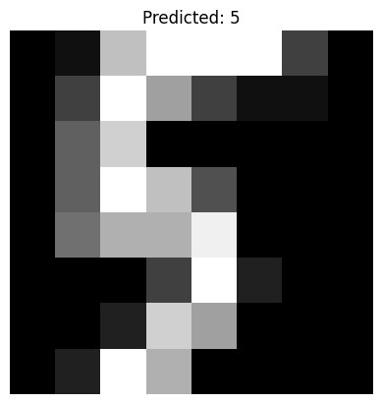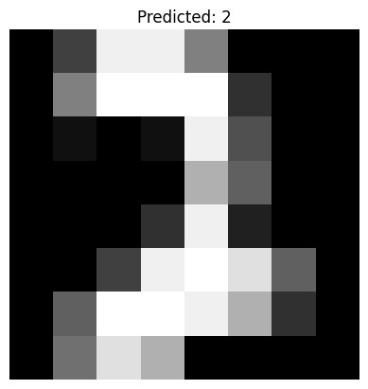

Slip 6
# Applying hierarchical clustering to group customer segments based on their # purchasing behavior.
# a) Import the “Mall Customers” data and plot Visualizations.
# b) Carry out the required steps of data pre-processing.
# c) Install the model and fit it on the data according to the parameters. # d) Show the final visualization of the dendogram by defining the function # for the same.
In [42]:
# ==============================
# Step 1: Import Libraries
# ==============================
import pandas as pd import numpy as np
import matplotlib.pyplot as plt import seaborn as sns
from sklearn.preprocessing import LabelEncoder from sklearn.preprocessing import StandardScaler from sklearn.cluster import AgglomerativeClustering from scipy.cluster.hierarchy import dendrogram, linkage
# ==============================
# Step 2: Import Dataset
# ============================== data = pd.read_excel("clustering.xlsx")
print("First 5 Rows") print(data.head())
print("\nDataset Info") print(data.info())
print("\nStatistical Summary") print(data.describe())
# ==============================
# Step 3: Data Visualization
# ==============================
# Income vs Spending Score plt.figure()
plt.scatter(data["AnnualIncome"], data["SpendingScore"]) plt.xlabel("Annual Income") plt.ylabel("Spending Score") plt.title("Income vs Spending Score")
In [43]:

plt.show()
# Age distribution plt.figure()
sns.histplot(data["Age"], bins=20, kde=True) plt.title("Age Distribution") plt.show()
# ==============================
# Step 4: Data Preprocessing
# ==============================
# Convert Gender to numeric le = LabelEncoder()
data["Gender"] = le.fit_transform(data["Gender"])
# Remove CustomerID
data = data.drop("CustomerID", axis=1)
# Feature Scaling scaler = StandardScaler()
scaled_data = scaler.fit_transform(data)
# ==============================
# Step 5: Dendrogram Function
# ============================== def plot_dendrogram(data): linked = linkage(data, method='ward')
plt.figure(figsize=(10,6)) dendrogram(linked)
plt.title("Customer Segmentation Dendrogram")
plt.xlabel("Customers") plt.ylabel("Distance") plt.show()
# Call dendrogram function plot_dendrogram(scaled_data)
# ==============================
# Step 6: Fit Hierarchical Model # ============================== model = AgglomerativeClustering(n_clusters=5) clusters = model.fit_predict(scaled_data)

data["Cluster"] = clusters
print("\nClustered Data") print(data.head())
# ==============================
# Step 7: Final Cluster Visualization
# ============================== plt.figure()
plt.scatter(data["AnnualIncome"], data["SpendingScore"], c=data["Cluster"])
plt.xlabel("Annual Income") plt.ylabel("Spending Score")
plt.title("Customer Segments (Hierarchical Clustering)") plt.show()

First 5 Rows
CustomerID AnnualIncome SpendingScore Age Gender MembershipYears \
- 1 100569 11 26 Male 15
- 2 57220 51 25 Female 12
- 3 99062 83 19 Male 14
- 4 83251 64 36 Female 5
- 5 15063 33 58 Female 2
PurchaseFrequency
- 11
- 37
- 2
- 15
- 17
Dataset Info
<class 'pandas.core.frame.DataFrame'>
RangeIndex: 1000 entries, 0 to 999 Data columns (total 7 columns):
# Column Non-Null Count Dtype
--- ------ -------------- -----
- CustomerID 1000 non-null int64
- AnnualIncome 1000 non-null int64
- SpendingScore 1000 non-null int64
- Age 1000 non-null int64
- Gender 1000 non-null object
- MembershipYears 1000 non-null int64
- PurchaseFrequency 1000 non-null int64 dtypes: int64(6), object(1) memory usage: 54.8+ KB None
Statistical Summary
CustomerID AnnualIncome SpendingScore Age MembershipYears
\
count 1000.000000 1000.000000 1000.000000 1000.00000 1000.000000 mean 500.500000 66088.510000 49.725000 43.40600 10.137000 std 288.819436 30445.776406 28.109705 14.97496 5.543551 min 1.000000 15063.000000 1.000000 18.00000 1.000000 25% 250.750000 38554.500000 26.000000 30.00000 5.000000
50% 500.500000 66141.000000 49.000000 43.00000 10.000000 75% 750.250000 93336.250000 73.000000 56.00000 15.000000 max 1000.000000 119898.000000 99.000000 69.00000 19.000000
PurchaseFrequency count 1000.00000 mean 25.17500 std 14.32395 min 1.00000 25% 13.00000
50% 26.00000 75% 38.00000 max 49.00000



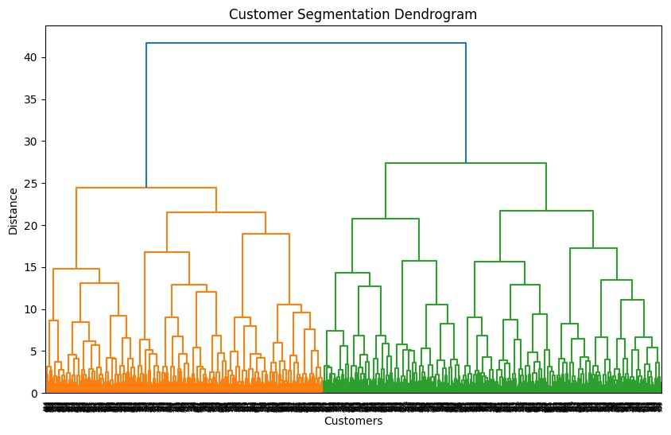
Clustered Data
AnnualIncome SpendingScore Age Gender MembershipYears \
- 100569 11 26 1 15
- 57220 51 25 0 12
- 99062 83 19 1 14
- 83251 64 36 0 5
- 15063 33 58 0 2
PurchaseFrequency Cluster
- 11 4
- 37 0
- 2 4
- 15 0
- 17 2
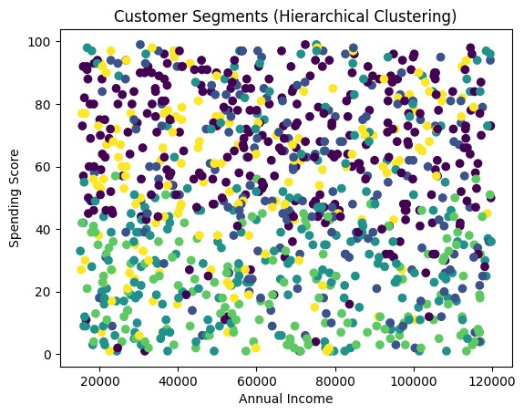
Slip 7
# Developing a Support Vector Machine (SVM) model to classify email # messages as spam or not spam.
# a) Import the “Spam Classification” data and also install the necessary # libraries related to NLP.
# b) Define the necessary pre-processing functions and delete the # duplicates if any.
# c) Split the data into training and testing, also extract important features
# d) Train the data on SVM algorithm and find out the Accuracy Score and # Confusion Matrix by making predictions on the test data.
In [44]:
# ==============================
# Step 1: Import Libraries
# ==============================
import pandas as pd import numpy as np
import matplotlib.pyplot as plt import seaborn as sns
# NLP libraries import re import nltk
In [45]:

from nltk.corpus import stopwords from nltk.stem import PorterStemmer
# Feature extraction
from sklearn.feature_extraction.text import TfidfVectorizer
# Model
from sklearn.svm import SVC
# Train/Test split
from sklearn.model_selection import train_test_split
# Evaluation
from sklearn.metrics import accuracy_score, confusion_matrix
# Download stopwords nltk.download('stopwords')
# ==============================
# Step 2: Import Dataset
# ============================== data = pd.read_csv("spam.csv", encoding="latin-1")
print("First 5 rows:") print(data.head())
print("\nDataset Info:") print(data.info())
# Keep only required columns data = data[['label','message']]
# ==============================
# Step 3: Remove Duplicates
# ============================== data = data.drop_duplicates() print("\nDataset Shape After Removing Duplicates:", data.shape)
# ==============================
# Step 4: Data Visualization
# ==============================
plt.figure() sns.countplot(x='label', data=data) plt.title("Spam vs Ham Distribution")

plt.show()
# ==============================
# Step 5: Text Preprocessing Function
# ============================== ps = PorterStemmer() def preprocess(text):
text = text.lower()
text = re.sub('[^a-zA-Z]', ' ', text) words = text.split() words = [ps.stem(word) for word in words if word not in stopwords.words('e return " ".join(words)
# Apply preprocessing
data['clean_message'] = data['message'].apply(preprocess)
# ==============================
# Step 6: Convert Text to Features
# ============================== tfidf = TfidfVectorizer(max_features=3000)
X = tfidf.fit_transform(data['clean_message']).toarray()
# Convert labels to numeric
y = data['label'].map({'ham':0,'spam':1})
# ==============================
# Step 7: Train-Test Split
# ==============================
X_train, X_test, y_train, y_test = train_test_split( X, y,
test_size=0.2, random_state=42
)
# ==============================
# Step 8: Train SVM Model
# ============================== model = SVC(kernel='linear')

model.fit(X_train, y_train) print("\nModel Training Completed")
# ==============================
# Step 9: Predictions
# ============================== y_pred = model.predict(X_test)
# ==============================
# Step 10: Evaluation
# ============================== accuracy = accuracy_score(y_test, y_pred) cm = confusion_matrix(y_test, y_pred) print("\nAccuracy Score:", accuracy)
print("\nConfusion Matrix:") print(cm)
# ==============================
# Step 11: Confusion Matrix Plot # ==============================
plt.figure()
sns.heatmap(cm, annot=True, fmt="d", cmap="Blues") plt.xlabel("Predicted") plt.ylabel("Actual") plt.title("Confusion Matrix")
plt.show()
First 5 rows: label message
- ham Go until jurong point, crazy.. Available only ...
- ham Ok lar... Joking wif u oni...
- spam Free entry in 2 a wkly comp to win FA Cup fina...
- ham U dun say so early hor... U c already then say...
- ham Nah I don't think he goes to usf, he lives aro...
Dataset Info:
<class 'pandas.core.frame.DataFrame'>
RangeIndex: 5169 entries, 0 to 5168 Data columns (total 2 columns):
# Column Non-Null Count Dtype
--- ------ -------------- -----
- label 5169 non-null object
- message 5169 non-null objectdtypes: object(2) memory usage: 80.9+ KB None
Dataset Shape After Removing Duplicates: (5169, 2)
[nltk_data] Downloading package stopwords to /root/nltk_data...
[nltk_data] Package stopwords is already up-to-date!
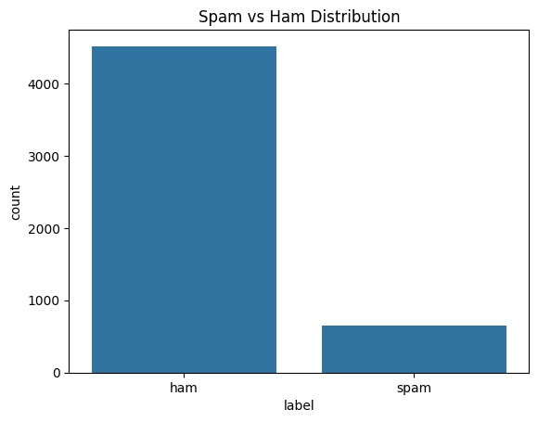
Model Training Completed
Accuracy Score: 0.9845261121856866
Confusion Matrix:
[[887 2]
[ 14 131]]
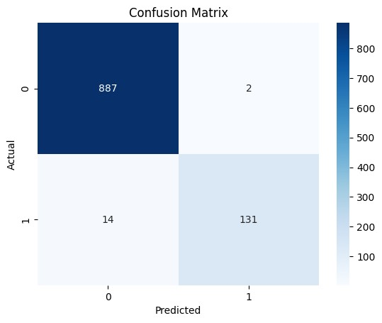
# ==============================
# Step 1: Import Libraries
# ==============================
import pandas as pd import numpy as np
import matplotlib.pyplot as plt import seaborn as sns
# NLP import re import nltk
from nltk.corpus import stopwords from nltk.stem import PorterStemmer
# Feature extraction
from sklearn.feature_extraction.text import TfidfVectorizer
# Model
In [46]:
from sklearn.naive_bayes import MultinomialNB
# Train/Test split
from sklearn.model_selection import train_test_split, GridSearchCV
# Evaluation
from sklearn.metrics import accuracy_score, confusion_matrix
# Download stopwords nltk.download('stopwords')
[nltk_data] Downloading package stopwords to /root/nltk_data...
[nltk_data] Package stopwords is already up-to-date!
Out[46]: True
# ==============================
# Step 2: Import Dataset
# ============================== data = pd.read_csv("IMDB.csv")
print("First 5 rows:") print(data.head())
print("\nDataset Info:") print(data.info())
print("\nSentiment Distribution:") print(data['sentiment'].value_counts())
In [47]:
First 5 rows: review sentiment
- One of the other reviewers has mentioned that ... positive
- A wonderful little production. <br /><br />The... positive
- I thought this was a wonderful way to spend ti... positive
- Basically there's a family where a little boy ... negative
- Petter Mattei's "Love in the Time of Money" is... positive
Dataset Info:
<class 'pandas.core.frame.DataFrame'>
RangeIndex: 50000 entries, 0 to 49999 Data columns (total 2 columns):
# Column Non-Null Count Dtype
--- ------ -------------- -----
- review 50000 non-null object
- sentiment 50000 non-null objectdtypes: object(2) memory usage: 781.4+ KB None
Sentiment Distribution: sentiment positive 25000 negative 25000 Name: count, dtype: int64
# Import libraries import pandas as pd
from sklearn.model_selection import train_test_split, GridSearchCV from sklearn.feature_extraction.text import CountVectorizer from sklearn.naive_bayes import MultinomialNB
from sklearn.metrics import accuracy_score, confusion_matrix
# a) Import dataset df = pd.read_csv("IMDB.csv") print(df.head())
# b) Data preprocessing df = df.drop_duplicates()
X = df["review"] y = df["sentiment"]
# Convert text labels to numbers y = y.map({"positive":1, "negative":0})
# Convert text to numerical features vectorizer = CountVectorizer(stop_words="english")
X = vectorizer.fit_transform(X)
# Split dataset
X_train, X_test, y_train, y_test = train_test_split(
In [48]:
X, y, test_size=0.2, random_state=42
)
# c) Train Naïve Bayes model model = MultinomialNB() model.fit(X_train, y_train)
# Prediction
y_pred = model.predict(X_test)
# d) Evaluation
print("Accuracy:", accuracy_score(y_test, y_pred)) print("Confusion Matrix:")
print(confusion_matrix(y_test, y_pred))
# Hyperparameter tuning
param_grid = {"alpha":[0.1,0.5,1.0]} grid = GridSearchCV(MultinomialNB(), param_grid, cv=5) grid.fit(X_train, y_train) print("Best Parameter:", grid.best_params_)
review sentiment
- One of the other reviewers has mentioned that ... positive
- A wonderful little production. <br /><br />The... positive
- I thought this was a wonderful way to spend ti... positive
- Basically there's a family where a little boy ... negative
- Petter Mattei's "Love in the Time of Money" is... positive
Accuracy: 0.8568115357466976 Confusion Matrix:
[[4319 620]
[ 800 4178]]
Best Parameter: {'alpha': 1.0}
In [48]:

